Arithmetic operations using 8085 microprocessor
Harini G
192524011

a. 8-BIT ADDITION WITH CARRY USING DIRECT ADDRESSING
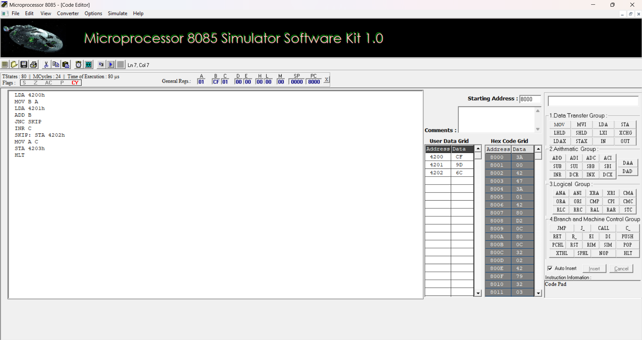
b. 8-BIT ADDITION USING INDIRECT ADDRESSING
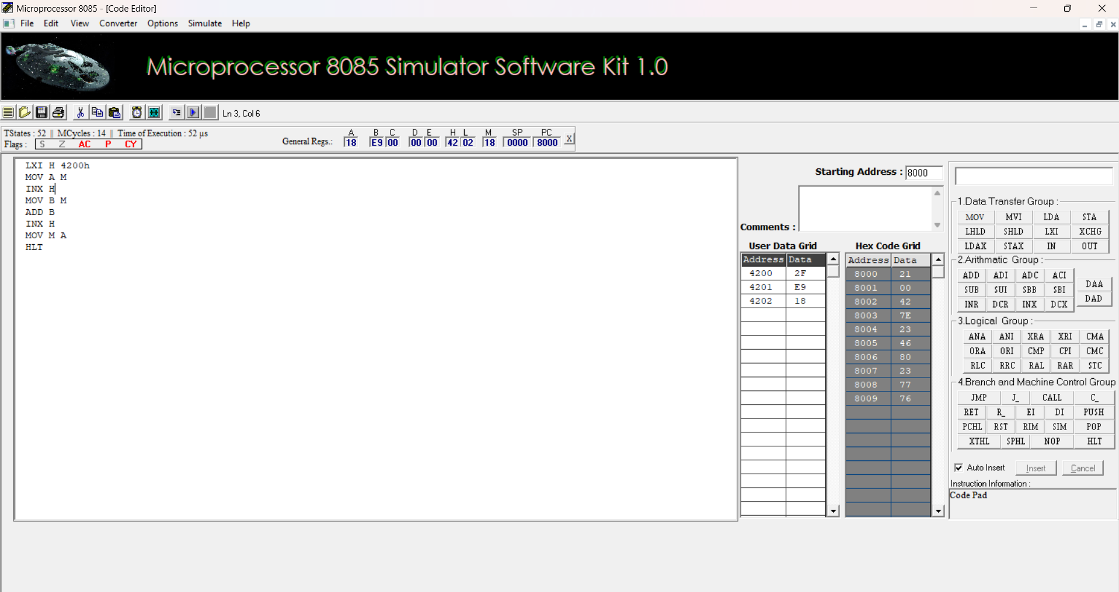

c. 8-BIT SUBTRACTION WITHOUT BORROW
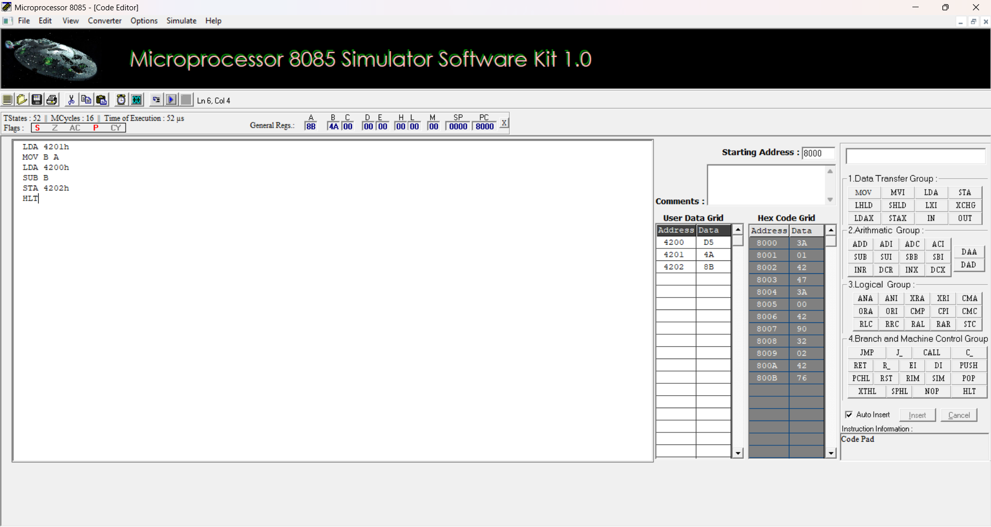
d. 8-BIT SUBTRACTION WITH BORROW USING DIRECT ADDRESSING
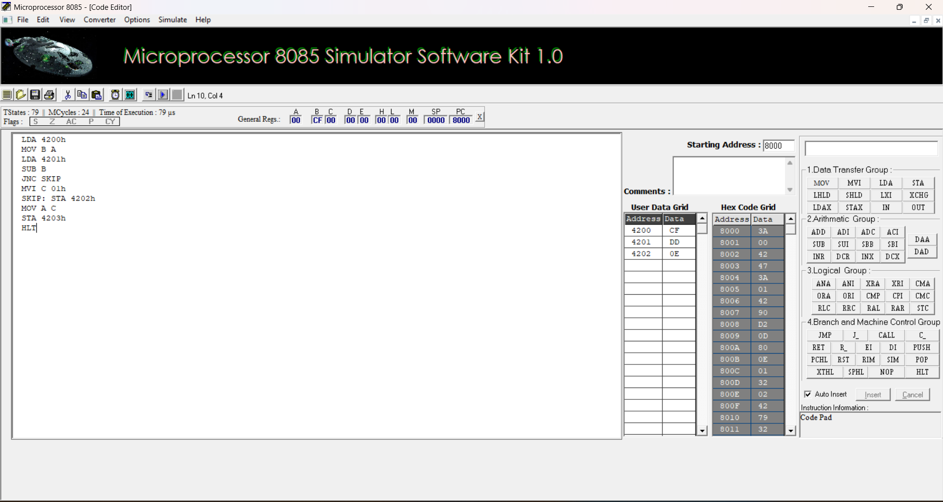

e. 8-BIT MULTIPLICATION OPERATIONS USING 8085 MICROPROCESSOR
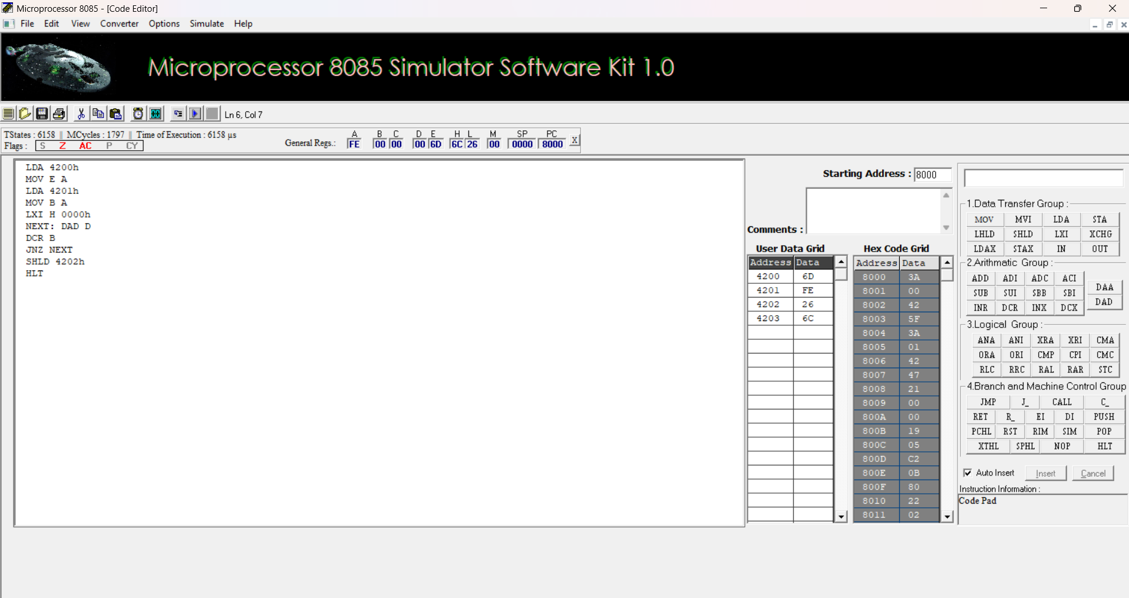
f. 8-BIT DIVISION OPERATIONS USING 8085 MICROPROCESSOR
